Victor Gregory Matos  
CSD340-J308  
Professor Sue Sampson

1.2 Assignment

Github link: <https://github.com/VGregoryBellevue/CSD-340>

Github Screenshot:   
  
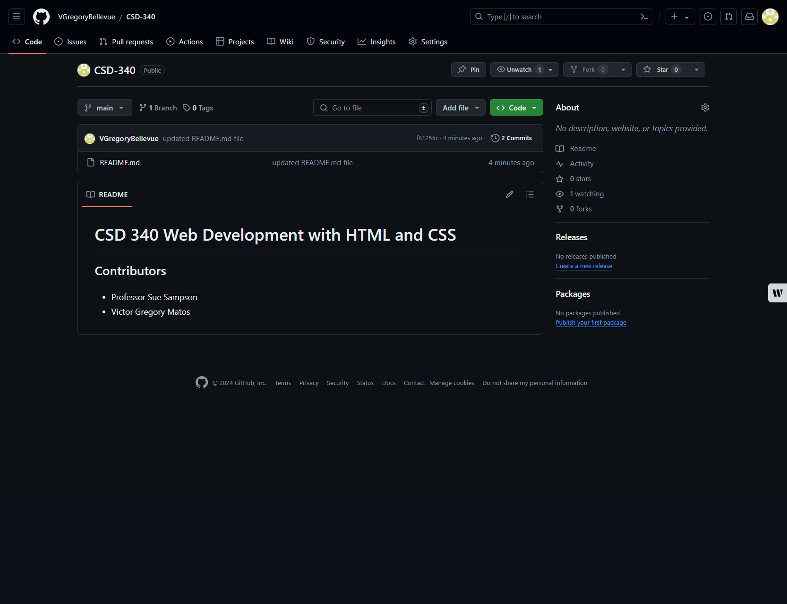

Terminal Directory

